Sodium Potassium Pump

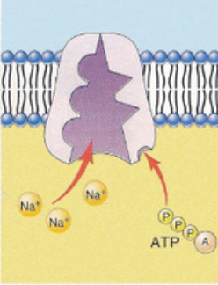 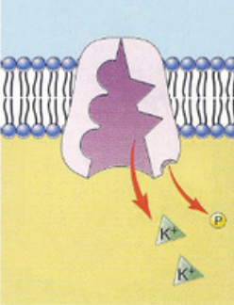

Sequence #______________

Summary: _________________________

__________________________

__________________________

__________________________

Sequence #______________

Summary: _________________________

__________________________

__________________________

__________________________

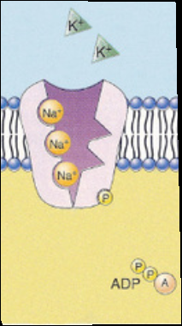 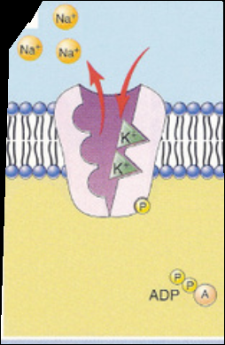

Sequence #______________

Summary: _________________________

__________________________

__________________________

__________________________

Sequence #______________

Summary: _________________________

__________________________

__________________________

__________________________