**Meiosis and Sexual Reproduction: Practice**

1. The diploid cells of a mouse contains 12 chromosomes. How many chromosomes will be found in haploid cells of the mouse?
2. The diploid cells of a bird contains 16 chromosomes. How many chromosomes will be found in sperm cells?
3. A duck’s haploid cells contain 14 chromosomes. How many chromosomes will be found in the diploid cells of the duck?
4. A tree’s leaf cell contains 20 chromosomes. How many chromosomes will be found in pollen from the tree?
5. The diploid number of a chicken’s cells is 14. If a cell undergoes meiosis, what is the resulting chromosome number?
6. The tongue cell of an alligator has 8 chromosomes. If the tongue cell undergoes mitosis, how many chromosomes will be found in each of the two daughter cells?
7. What is the number of chromosomes found in a human skin cell? A human sperm cell?
8. Identify the following pictures as either sexual or asexual reproduction

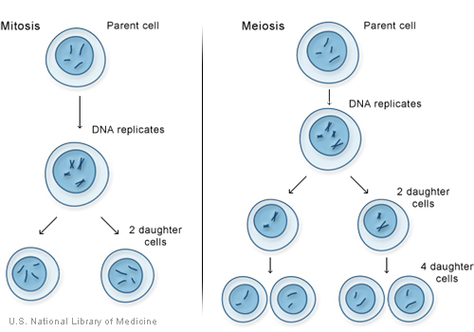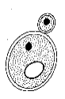 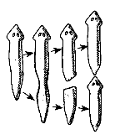 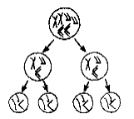

________________ _______ _____________ ________________

**Use the following diagram to answer the questions.**



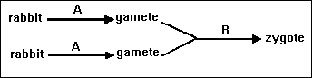

1. What type of cell division does A represent?
2. Are the gametes produced after “A” 2n or n?
3. Are the gametes diploid or haploid?
4. Suppose the rabbit’s body cells contained 10 chromosomes, how many chromosomes would a gamete contain?
5. Suppose the gamete’s contained 12 chromosomes, how many chromosomes would a somatic cell contain?
6. What is it called when gametes combine genetic material in part B?

1. What type of reproduction is occurring in this diagram?

1. Does it lead to genetic stability or variation in offspring?

1. After the zygote has formed, what type of cell division occurs that allows it to grow into an embryo?

1. Is the zygote formed by mitosis, meiosis, or fertilization?

1. Is the zygote diploid or haploid? 2n or n?
2. A scientist is trying to test how genetic mutations are passed on to offspring. Mouse A’s sperm cells are exposed to radiation. Mouse B’s skin cells are only exposed to radiation. Which mouse could pass on genetic mutations to their offspring? Explain.