**Midterm Study Guide Name: ________________________**

S. Method, Characteristics of Life, Biochemistry, Cells, Cell Division, Transport, Photosynthesis, Respiration, DNA Structure, and the Cell Cycle

**Scientific Method**

1. If you wanted to conduct an experiment to see under which color light plants grew the best, what would the control group be? The plants under _______________ light.
   1. What would the independent variable be? ________________________
   2. What would be an example of a control, not the control group! __________________
2. Mrs. Fairweather’s small garden has many weeks and she is tired of pulling them! She divided her garden into 3 even areas and uses Weed-B-Gone on the 1st area, organic herbicide on the 2nd area, and leaves the 3rd area alone. After 2 weeks of treatment, the 1st area of her garden has 18 weeds left, the 2nd area has 42 weeds left, and the 3rd area has 182 weeds left.
   1. What is Mrs. Fairweather’s scientific problem?_______________________________
   2. What is her independent variable?_________________________________________
   3. What is her dependent variable?___________________________________________
   4. Which is her control group?______________________________________________
   5. Why is a control group necessary?_________________________________________
   6. Why is the scientific method important in science?_____________________________ ____________________________________________________________________

**Biochemistry**

1. Acids have pH of ___ to ___ and some examples of acids are _______________________.
2. Bases have pH of ___ to ___ and some examples of bases are _______________________.
3. What are the 4 major organic compounds found in living things?
4. Which element is found in organic compounds? __________
5. Enzymes are a type of _______________ that _____________ up chemical reactions.
6. Enzymes will attach to a ________________ and will either break it into pieces or enzymes can take two compounds and synthesize them _____________________.
7. Draw and label each of the organic molecules. Remember, there are 2 for lipids.
8. Fill in the chart below:

|  |  |  |  |  |
| --- | --- | --- | --- | --- |
| **Organic Compound** | **Monomer** | **Polymer Called** | **Job in Cells** | **Test Used** |
| Nucleic Acids |  | (2 types)  1)  2) |  | None |
| Proteins |  | (2 types)  1)  2)Polypeptide |  |  |
| Carbohydrates |  | Poly___________ |  | (2 types)  1)  2) |
| Lipids | 3 different ones:  a)  b)  c) | (3 kinds)  1)  2)  3) |  |  |

1. Label the diagram below using the following words: *enzyme, enzyme-substrate complex, substrate, and products.*

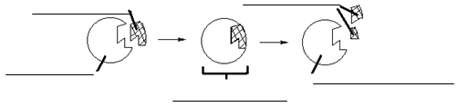

1. Read the graph below then answer the questions.

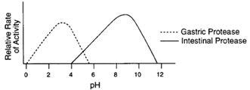

* 1. What is the optimal pH for gastric protease? __________________________
  2. What is the optimal pH for intestinal protease? _________________________
  3. Which enzyme works best in a basic pH? ______________________________
  4. Which enzyme would work best in your stomach? _______________ Why? ______ __________________________________________________________________
  5. Which enzyme works best in water? ______________________ Why? __________ __________________________________________________________________
  6. From this graph, can you tell the optimal temperature for these enzymes? __________ Why/why not? _______________________________________________________

**Cells & Transport**

1. What are the 2 types of cells and what makes them different?__________________________
2. What structure of the cell is “selectively permeable”? ______________________________
3. What kind of organism has a prokaryotic cell? ___________________________________
4. In what organelle does photosynthesis occur? ____________________________________
5. What are the three parts of the above organelle?
   1. 1) __________________ 2)___________________ 3)_____________________
   2. Draw and label this organelle.
6. What is the 3 difference between a prokaryote and a eukaryote?
7. What cell structure is the most responsible for maintaining the cell’s homeostasis? _________
8. As the size of a cell increases, its volume increases faster than its _______________________
9. What is the purpose of a microscope? ___________________________________________
10. If the eyepiece of your compound light microscope has a 10x magnification and the objective you are using has 100x magnification, how many times larger than real-life is the image produced? _____________________
11. How would you calculate the total magnification of a specimen on a slide being viewed under a microscope? _____________________________________________________________
12. What makes a compound organic? ____________________
13. List the 3 parts of the Cell Theory:
14. Describe the functions of the following organelles/cell parts:
    1. Nucleus
    2. Smooth Endoplasmic Reticulum
    3. Rough Endoplasmic Reticulum
    4. Nucleolus
    5. Lysosome
    6. Vacuole
    7. Cell Membrane
    8. Ribosomes
    9. Centrioles
    10. Chromatin
    11. Chloroplast
    12. Mitochondria
15. What two structures are only found in plant cells?
16. What structure is only found in animal cells?
17. How do cells communicate?
18. What determines the specialization of a cell?
19. What is the overall purpose of a cell?
20. Label the cell pictures below. Determine if each is a bacteria, plant, or animal cell and whether is it eukaryotic or prokaryotic.

1.

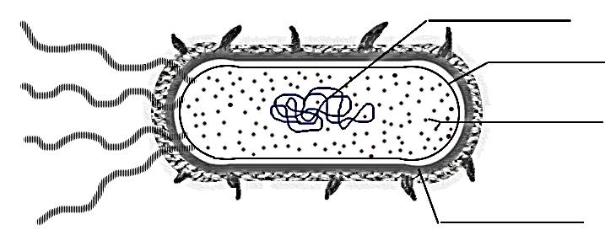

2.

3.

4.

Type of Cell: ______________________

Eukaryotic or Prokaryotic? ______________________________

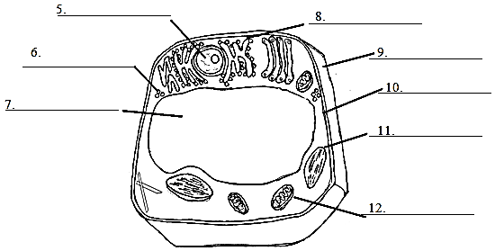

Type of Cell: ______________________

Eukaryotic or Prokaryotic? ______________________________

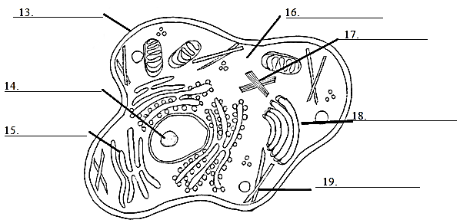

Type of Cell: ______________________

Eukaryotic or Prokaryotic? ______________________________

1. In the following Venn diagram, write where the following words would be placed: *cell wall, centrioles, chloroplasts, eukaryotes, prokaryotes, cell membrane, no cell wall, cytoplasm, DNA, nucleus, no nucleus, ribosomes, many different organelles.*

Animal Cell

Plant Cell

Bacteria Cell

1. Fill out the chart below using these terms: *facilitated diffusion, osmosis, endocytosis, channel proteins, pumps, diffusion, exocytosis, carrier proteins, uses ATP, does not use ATP, moves particles in and out of the cell.*

|  |  |  |
| --- | --- | --- |
| **Active Transport** | **Both** | **Passive Transport** |
|  |  |  |

1. What type of transport moves particles from high to low solute concentration? ___________
2. What type of transport moves particles against the concentration gradient? _______________
3. Draw the following:
   1. A blood cell in a high-solute solution:
   2. A blood cell in pure water:
4. Water always flows from ________ to __________ solute concentration.
5. In a solution of salt water, ________________ is the solute and _______________ is the solvent. The salt is said to be ___________________ in water (starts with a “d”).
6. Define & give an example of each:
   1. Hypertonic:
   2. Hypotonic:
   3. Isotonic:

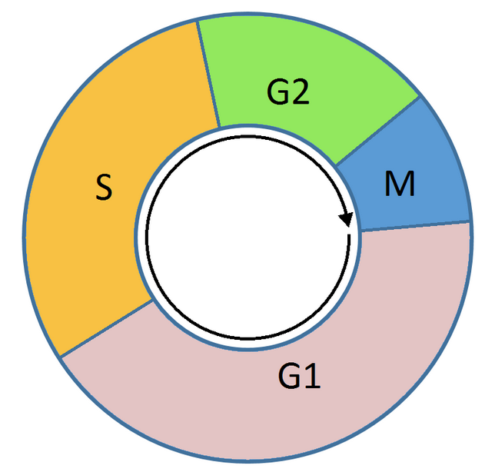**Cell Division: Mitosis**

1. What three phases of the cell cycle are considered interphase? Where do cells spend the most amount of time?

2. Name the steps of mitosis in order.

3. Complete the two charts below.

|  |  |  |
| --- | --- | --- |
| **Phase** | **Events of phase** | **Picture** |
| Interphase |  |  |
| Prophase |  |  |
| Metaphase |  |  |
| Anaphase |  |  |
| Telophase |  |  |
| Cytokinesis |  |  |

4. How is cytokinesis in plant cells different from cytokinesis in animal cells?

5. In what cell type(s) does mitosis take place?_______________________________________

6. Number the following diagrams in the order that they would occur in mitosis.

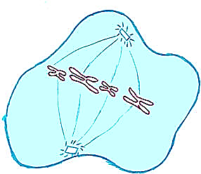 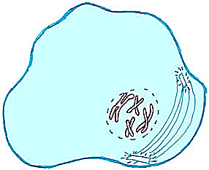 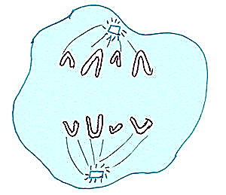 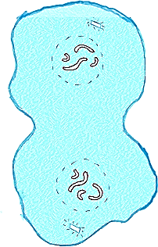



7. Identify the picture to the right as sexual or asexual reproduction. Tell why you identified it this way.

8. Name an organism and describe a method of asexual reproduction used by that organism.

9. What is another name for asexual cell reproduction?

10. What is the purpose of mitosis?

11. What causes cancer?

14. What is cancer?

**Photosynthesis & Respiration**

1. Fill in the following chart with the correct information:

|  |  |  |
| --- | --- | --- |
|  | **Photosynthesis** | **Respiration** |
| Function: | To make _______ from ________ | To convert ___________ into _____________ |
| Organelle: |  |  |
| Reactants: |  |  |
| Products: |  |  |
| Chemical Equation: |  |  |

1. A student fills a beaker with water, Elodea (a water plant) in an upside down test tube, and sets the beaker under a lamp. She waits several hours and finds the test tube has a bubble at the top.
   1. What gas filled the test tube? ________________________
   2. The gas was a waste product of what process? _______________
   3. Why did she place the beaker under the lamp? ______________________________
2. A student fill a test tube with a sugar solution and yeast, and place a small test tube inverted inside the larger one. Then the student places the test tubes in a warm location for several hours to allow bubble to collect at the top.
   1. What gas was collected? _________________________________
   2. The gas was a waste produce of what process, be specific? ___________________________

Use the diagram of ATP provided to answer the following questions.

1. The cell uses ATP for what? ____________________________
2. 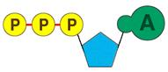**Where** is ATP made? _________________________________
3. What **organic compound** is broken apart to make ATP? ______
4. What **process** makes ATP? ____________________________
5. Where is energy stored in an ATP molecule? Circle it in the diagram.
6. In aerobic respiration, _____________________ is needed.
7. In anaerobic respiration, ___________________ is **NOT** needed.
8. Which type of respiration is the **most efficient**? ______________________________
9. What type of respiration is used by yeast and bacteria? _________________________
10. Do all organisms carry out respiration (yes or no)? ___________
11. **Draw** a picture of a mitochondrion in the box to the right.

**DNA Structure:**

1. If one side of DNA is GCATCCGAA, the complementary strand is: ____________________

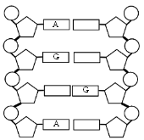For the diagram below, follow the directions listed in order to label the DNA molecule.

1. Use the letter **P** to label all the phosphate groups.
2. Use an **S** to label all the sugar molecules.
3. For labeling the nitrogen bases, use a **T** for thymine and **C** for cytosine. Guanine and adenine have been labeled for you.
4. **Circle** and **label** a codon.
5. **Circle** and **label** a nucleotide.
6. Put the following in order from large to small: DNA, cell, nucleotides, chromosomes, genes, nucleus.
7. A DNA strand is **TAC-CGC-GTA-GGA-ACT**
   1. Give the complementary DNA strand:
   2. **Transcribe** the original strand:
   3. **Translate** the mRNA from letter b.:

STERNGRR

1. List the characteristics of all living things and provide an example:

1) S

2) T

3) E

4) R

5) N

6) G

7) R

8) R

1. What is homeostasis? Give two specific examples of how your body maintains homeostasis.