**Kingdom Plantae**

**While plants are very diverse, there are several characteristics that they all share:**

* They are all ____________________________ (made up of many cells)
* They are all __________________________ their cells contain a nucleus & membrane bound organelles
* Their cells are surrounded by a ___________ _____________made of __________________, a large carbohydrate.
* Are ____________________________ that undergo photosynthesis (they make their own food);
* Their green color comes from a pigment called __________________________________.

**Most primitive plants most complex plants**

**[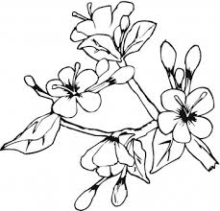](http://www.google.com/imgres?q=blooming+flowers&um=1&hl=en&rlz=1T4DKUS_enUS272US274&biw=1280&bih=634&tbm=isch&tbnid=P-p5e1iy0qnNiM:&imgrefurl=http://www.supercoloring.com/pages/blooming-flowers-in-may/&docid=MLFxWoNaFUTW9M&w=364&h=350&ei=rCdpTvLqOsbc0QG2ntTHCw&zoom=1)**

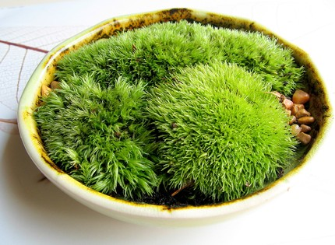

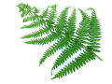

[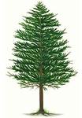](http://www.etchingsetc.net/images/pinetree_huge.jpg)

* Plants are thought to have evolved from __________________ (an aquatic plant-like protist)
* To survive on land, plants needed a waterproof layer called a __________________________ .
* **Mosses are called __________________________________plants since they do not** have veins.
* These plants must grow low to the ground. They absorb their nutrients and water directly from the ground.
* **Vascular plants** have veins (like the blood vessels in your body) that allow for movement of material throughout the plant. Two kinds of vascular tissue allow for this movement:
  + ________________ - transports _______________ up from the roots to the leaves.
  + ______________- transports _______________ down to store & up to use.

**A piece of celery has been placed into water with food coloring in it – describe what you see:** __________________________________________________________________  
______________________________________________________________________

Because of their veins, vascular plants are able to have true organs such as:

|  |  |
| --- | --- |
| Organ | Purpose |
|  | Absorbs nutrients & water from the environment; anchors the plant to the ground |
|  | Allows plant to grow upright toward the sun |
|  | Acts like solar panels; absorbing sunlight needed for photosynthesis. |

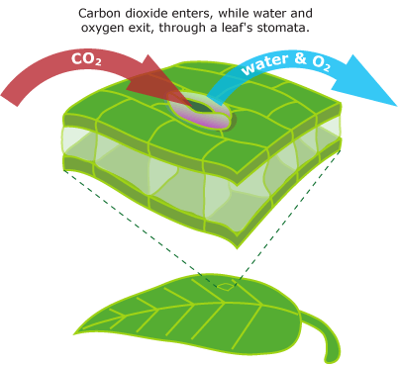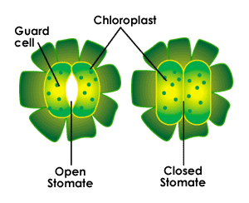Plants maintain water ______________ by opening and closing holes called _____________ on their leaves. In dry conditions or during the heat of the day plants can close these holes to prevent water loss. If a plant has an excess of water, then the holes remain open and water can exit the leaves through the holes.

**Why do plants need carbon dioxide?**

[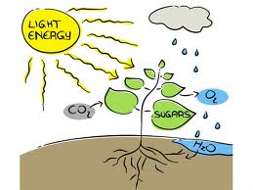](http://www.google.com/imgres?q=photosynthesis+pictures&hl=en&sa=X&tbo=d&rls=com.microsoft:en-us:IE-SearchBox&biw=1280&bih=619&tbm=isch&tbnid=oGqc2yeYjtyU9M:&imgrefurl=http://www.earthtimes.org/energy/photosynthesis-dream-renewable-energy/1956/&docid=ACkHwfURPJ_PZM&imgurl=http://www.earthtimes.org/newsimage/photosynthesis-dream-renewable-energy_1_02842012.jpg&w=765&h=574&ei=kW_5UMjFI4PW9ASkzICQAQ&zoom=1&iact=hc&vpx=691&vpy=213&dur=2500&hovh=194&hovw=259&tx=128&ty=133&sig=114611842938778161358&page=2&tbnh=144&tbnw=192&start=20&ndsp=28&ved=1t:429,r:24,s:0,i:189)Plants take in carbon dioxide and release oxygen through holes on their leaves. _______________________ is taken in. Water has traveled from the _________________ into the leaves and light shines down on the leaves. The carbon dioxide, water and light are all the necessary ingredients for ______________________. Glucose and ___________________are products of this reaction. The oxygen exits through the holes of the leaves. Some of the glucose is converted into useable energy for the plants’ life functions. The rest of the glucose is used to build structures inside of the plant.

**Equation for photosynthesis:**

______________________________________________________________________

**Adaptation -** In a tropical rain forest very little light penetrates through the canopy of the trees down to the forest floor. An adaptation of some of the plants living here are very large leaves. Explain how large leaves are an adaptation for these plants. ______________________________________________________________________  
______________________________________________________________________

|  |  |  |  |  |  |
| --- | --- | --- | --- | --- | --- |
| **Review of 4 Main types of Plants –  Place an X in the box if the plant has the characteristic.** | | | | | |
|  | **Use** | **Mosses** | **Ferns** | **Gymnosperm** conifers – pines & spruces | **Angiosperm**  grasses, flowering trees & shrubs, & wildflowers |
| **Vascular tissue** | **Allows s plant to grow move water up so that it can grow up toward the sun** |  |  |  |  |
| **Seeds** | **A small baby plant covered in a seed coat for protection** |  |  |  |  |
| **Flowers** | **Contains reproductive organs of flowering plants** |  |  |  |  |

**Sexual Reproduction in Flowering Plants (Angiosperms):**

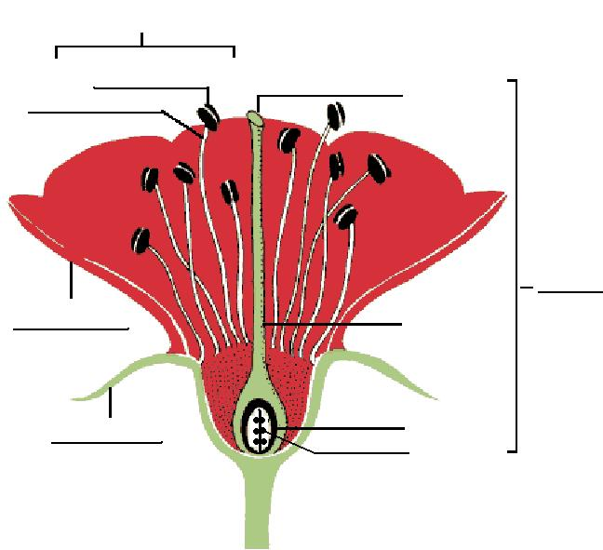

**After Pollination** occurs, a fertilized egg forms into an embryo inside of a _________________ with 3 basic parts:

1. 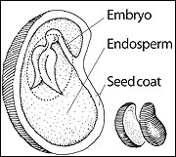_______________________ - another term for the baby (plant)
2. _______________________ - surrounds & protects the baby plant
3. _______________________ - the food that the embryo will consume to survive until it is able to grow leaves and use photosynthesis to make food.

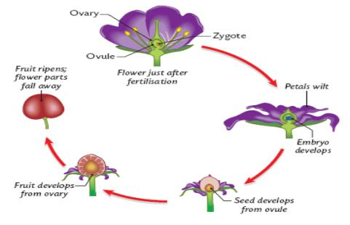

**Seed Dispersal =** moving seeds away from the parent plant to increase chances of survival.

Angiosperms have improved seed dispersal by developing different ways to spread their seeds further away from the parent plant.

* The OVARY ripens and forms into a ____________________ around the seed. Angiosperms have evolved to produce fruits of many shapes and sizes, each with the purpose to help disperse or spread the seeds
* ________________________ = the part of the plant that contains seeds.

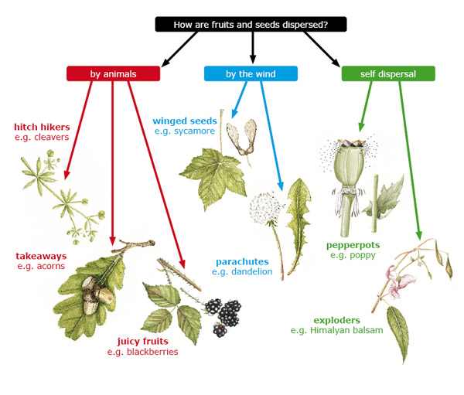

**Characteristics of seeds dispersed by:**

* Wind & water -_______________________________________________________________
* Animals - __________________________________________________________________

Once seeds are dispersed, they often enter a state of **dormancy**, ______________________ which increases a plants chance of survival:

* Factors that trigger a seed to end dormancy are: _______________ and _____________.

**Response to their environment:**

Plants grow, reproduce, and shift the position of their roots, stems and leaves in **response** to **environmental** conditions such as __________________________________________

* A ________________________is a plant’s response to an external stimulus.
* ____________________– growth of plant towards the light
* ____________________- direction of plant growth in response to gravity