**3.2.2 Predict offspring ratios based on a variety of inheritance patterns (including dominance, codominance, incomplete dominance, multiple alleles, and sex-linked traits).**

**Part A: Punnett Square Basics**

1. For each genotype below, indicate whether it is a ***heterozygous (He)*** OR ***homozygous (Ho)***.

TT _____ Bb _____ DD _____ Ff _____ tt _____ dd _____ Dd _____ ff _____ Tt _____ bb _____ BB _____ FF _____

2. Which of the genotypes in #1 would be considered purebred? _____________________________

3. Which of the genotypes in #1 would be hybrids? __________________________________________

4. Use the information for SpongeBob’s traits to write the phenotype (physical appearance) for each item.

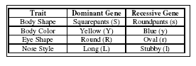

(a) LL-______________ (e) Rr-_______________

(b) yy-_______________ (f) ll- _______________

(c) Ss-_______________ (g) ss- _______________

(d) RR - _____________ (h) Yy -______________

5. Create a Punnett square to show the cross between a heterozygous Squarepants and a Roundpants. (Use the chart above to help determine the alleles.)

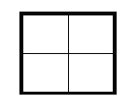

a. What is the ratio of Squarepants to Roundpants?

_______ Squarepants : ________ Roundpants

1. What is the genotype of the Squarepants children? _________
2. What is the genotype of the Roundpants children? _________

6. SpongeBob’s aunt and uncle, SpongeWilma and SpongeWilbur, have the biggest round eyes in the family. Wilma is believed to be heterozygous for her round eye shape, while Wilbur’s family brags that they are a pure line. **Complete the Punnett square to show the possibilities that would result if SpongeWilma and SpongeWilbur had children.**

(a) Give the genotype for each person. Wilma - _______ Wilbur - ________



(b) Complete the Punnett square to show the possibilities that would result if they had children.

(c) What is the probability that the kids would have round eyes? ____ %

(d) What is the probability that the kids would be oval eyes? ____ %

**Part B: The Austrian Monk. (Mendelian Genetics)**

**Blue’s Clue Box:**  
Law of Dominance

Law of Independent Assortment

Law of Segregation



1. Who is considered to be the Father of Genetics?
2. Which of Mendel’s laws is demonstrated in the Punnett square below? Explain

what this law says is true about some alleles “masking” or “hiding” other alleles.

D

d

D

d

Dd

Dd

Dd

Dd

1. Which of Mendel’s laws is demonstrated in the following diagram? During which type of cell division (mitosis or meiosis) does this particular process occur? Determine how many alleles the gamete gets from the parent cell.

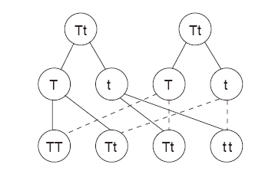

1. A parent sponge has yellow body color, a long nose, and is a Squarepants. During the process of meiosis, the gamete shows one dominant allele for yellow body color, a recessive allele for stubby nose, and a recessive allele for Roundpants. **Which of Mendel’s laws does this demonstrate?**

5. Examine the diagram and determine in which set of chromosomes independent (random) assortment can occur. Provide evidence to support your answer.

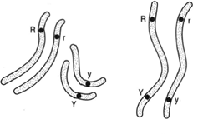

**Set A**

**Set B**

**Part C: Intermediate Inheritance and Polygenetics**

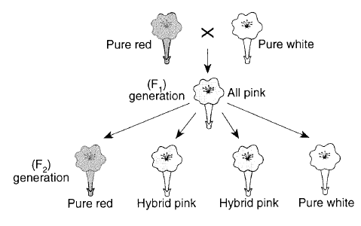

1. Look at the diagram to the right. What principle is illustrated?
2. Explain how the F1 generation is all pink. (You may draw a Punnett Square to explain your answer.)
3. Explain how the F2 generation can have red, white, AND pink flowers. (You may draw a Punnett Square to explain your answer.)
4. A cheetah expresses both the gene for dark hair and the gene for yellow hair. This might be considered an example of what type of dominance?
5. In certain types of cows, the gene for white coat color is dominant and the gene for red coat color is also dominant. Their offspring are called “roan” and have red and white spots. Predict the genotypic and phenotypic ratios of the F1 offspring of a male and female roan cow.
6. Sometimes a single gene can have more than one allele that might influence its expression. What is this called?
7. Complete the following chart for the multiple alleles of blood type.

|  |  |  |
| --- | --- | --- |
| **PHENOTYPE** | **HOMOZYGOUS ALLELE GENOTYPE** | **HETEROZYGOUS ALLELE GENOTYPE** |
| **A** |  |  |
| **B** |  |  |
| **AB** |  |  |
| **O** |  |  |

1. Which blood type is considered to be codominant?
2. Mrs. Echinoderm, Patrick’s wife has type A blood. Patrick has type O. Their little pink bundle of joy arrived and had type AB blood. Did Patrick’s wife cheat on him? Explain your answer by completing all possible Punnett Squares.

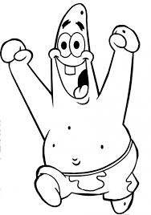

1. Most traits in humans are controlled by more than one set of genes. Explain how this curve demonstrates the polygenic results of height in a human population. In essence, what does polygenic inheritance look like if it is compared across a given population?

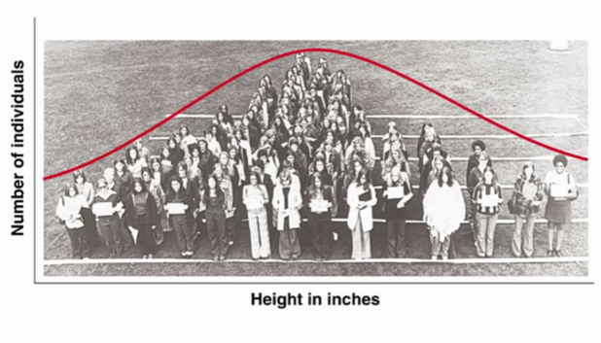

1. Red-green colorblindness is a recessive sex-linked trait. What is the probability that a colorblind man who marries a normal woman that is a carrier for color-blindness would produce a colorblind female child?
2. Hemophilia is also a recessive sex-linked trait. What would be the probability that a male with hemophilia and a normal female would have a son with hemophilia?

**Part D: Human Genetics**

**Blue’s Clue Box:**  
Autosomal Dominant

Autosomal Recessive

Sex-linked

Non-disjunction

Codominance



1. Complete the chart.

|  |  |
| --- | --- |
| **Disease** | **Method of inheritance** |
| Sickle- Cell Anemia |  |
| Huntington’s Disease |  |
| Down’s Syndrome |  |
| Hemophilia | When do you get tested for the disease PKU?  How can this disease be controlled? |
| Duchenne’s Muscular Dystrophy |  |
| Colorblindness |  |
| Kleinfelter’s Syndrome |  |
| Cystic Fibrosis |  |
| PKU |  |



2. Explain the relationship between sickle-cell disease and malaria. Why is there an advantage if you are heterozygous for sickle-cell and live in an area with many mosquitoes?

3. Match the appropriate genotypic and phenotypic characteristics to the diagram.

**A**

* genotype = SS
* not affected by disease
* can contract malaria

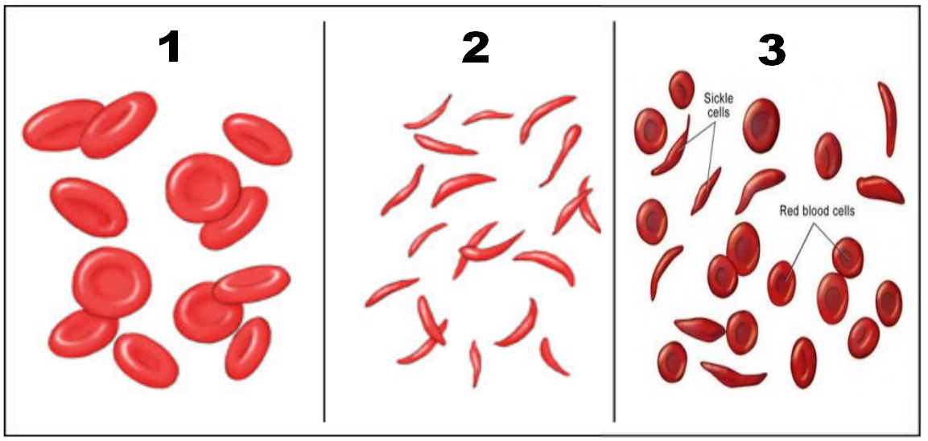

**B**

* genotype = ss
* has sickle cell disease
* cannot contract malaria

**C**

* genotype = Ss
* not affected by disease, but carrier
* cannot contract malaria

4. Examine the pedigree below.

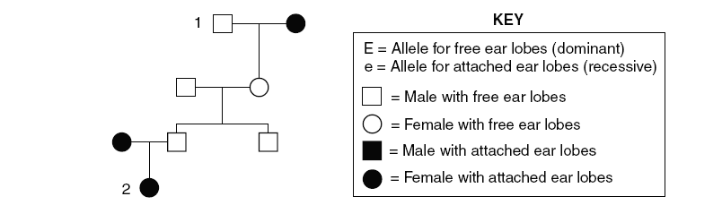

**3**

**4**

1. Give the genotypes of numbers 1-4.
2. Is the allele for attached earlobes autosomal dominant, autosomal recessive, or sex-linked?

5. Cindy married Jim. They had two children, Caroline and Johann. Caroline is not colorblind, but Johann is color -blind.

* 1. What can you surmise about Cindy from the information given?
  2. How is this disease transmitted?
  3. Draw a pedigree showing all the relationships.
  4. Cindy is adopted and has never met her father. What can you tell Cindy about her father & colorblindness.

6. Examine the karyotype to the right.



* 1. Is this child a male or female?
  2. Does this child have a genetic disorder? If so, which one, and how did you determine your answer? (Circle the problem area.)

**3.2.3 Explain how the environment can influence the expression of genetic traits.**

1. How might environment influence adaptations?

2. Snuzzles are small furry animals that live in the Hopewell Island. This is the only place they live. Most snuzzles like to eat worms, but some will eat worms and tree bark. One year the habitat experienced a drastic change. The temperatures were very high for long periods and the worms died out. What might have happened to the snuzzle population living on Hopewell Island?

3. List at least 5 substances that can be found in the environment that can affect gene expression.