DNA Mutations Guided Notes

What are Mutations?
Mutations are heritable changes in genetic information.

What Causes Mutations?
_______________: certain substances or conditions that can create a greater rate of mutation.
Some examples include:
- Viruses
- High temperatures
- _____________________ (UV rays)
- __________________________ (mustard gas, DDT, Agent-Orange)

Types of Mutations
All mutations fall into _____ basic categories:
- ________ ________________ produce changes in a single gene.
- _________________ ________________ produce changes in whole chromosomes.

Gene Mutations
_____________ mutations involve changes in one or a few nucleotides. This is because they occur at a single point in the DNA sequence. They generally occur _________ _______________.

If a gene in one cell is altered, the alteration can be passed on to every cell that _________________ from the _______________ _________.

Types of Gene Mutations
Point mutations are _______________.

Gene Mutations - Substitution
In a substitution, ______ _________ is changed to a ______________ ________.

Substitutions usually affect no more than a _________ ______ _______, and sometimes they have ____ _____________ at all.

Gene Mutations – Frameshift: Insertions and Deletions
Insertions and deletions are point mutations in which ______ _______ is ____________ or _____________ from the DNA sequence.

If a nucleotide is added or deleted, the bases are still read in groups of three, but now _______ ______________ _________ in every codon that follows the mutation.
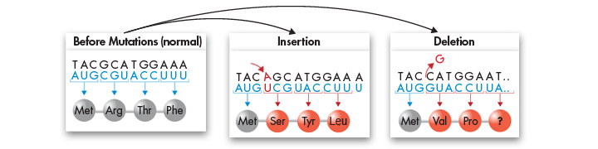
Chromosomal Mutations
Chromosomal mutations involve changes in the ___________ or ____________ of chromosomes.

These mutations can change the ____________ of genes on chromosomes and can even change the __________ of copies of some genes.

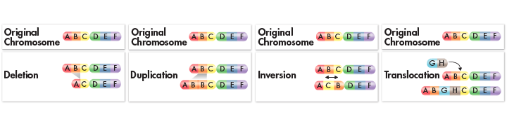
There are four types of chromosomal mutations: ____________, ____________, ____________, and ____________.
Chromosomal Mutations - Deletion
Deletion involves the loss of ____ or _______ of a ____________.

Chromosomal Mutations - Duplication
Duplication produces an _______ _______ of all or part of a ____________.

Chromosomal Mutations - Inversion
Inversion __________ the ____________ of parts of a ____________.

Chromosomal Mutations - Translocation
Translocation occurs when part of one chromosome ____________ off and ____________ to another.

How Do Mutations Affect Genes?
The effects of mutations on genes _______ ___________. Some have ______ or ___ effect; and some produce ________________ variations. Some negatively disrupt gene function.

Mutations often produce ___________ with _____ or ________ functions that can be useful to organisms in different or changing environments.

Effects of Mutations
-Genetic material can be altered by ___________ events or by ____________ means.
-The resulting mutations _____ or _____ ______ affect an organism.
-Many mutations are produced by ______ in genetic processes. For example, some ________ mutations are caused by errors during DNA replication.
-The cellular machinery that ___________ DNA inserts an incorrect base roughly _____ in every ___ _______ bases.
-Small _____________ in genes can gradually _____________ over time.

