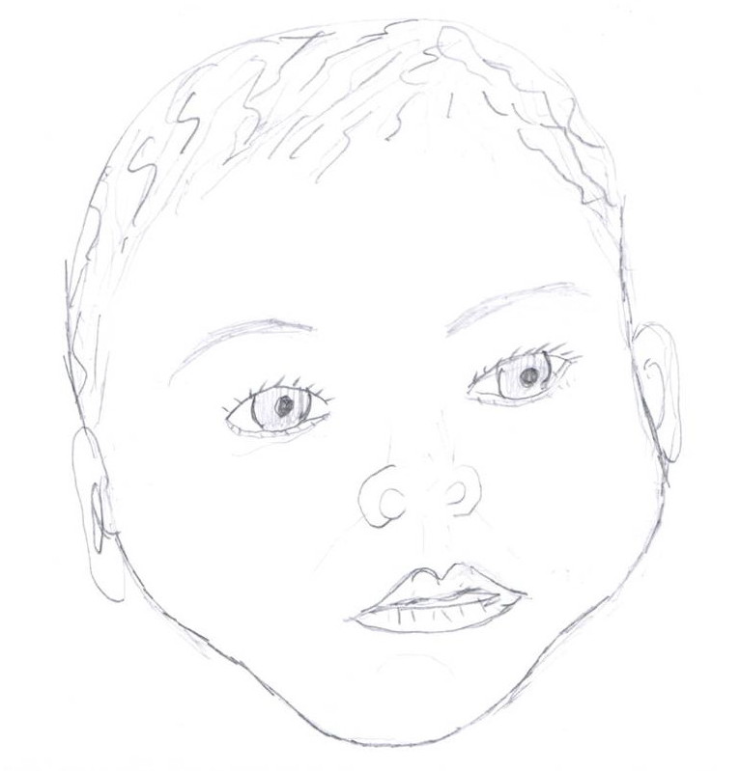

Create a Baby Lab Artwork by Maria Rascon
Purpose: To demonstrate the principles of Mendelian genetics and sex determination, including the concepts of allele, phenotype, genotype, dominant, recessive, codominant, homozygous and heterozygous by creating a simulated baby.
Materials: Two pennies, paper.
Procedure:
1) Working with a partner, determine the genotype of the baby by flipping pennies. "Mom" flips one penny to choose an allele for her egg and "Dad" flips the other to choose an allele for his sperm. (Note that the gender of the baby is a special case and is determined by dad alone. Boys are XY and girls are XX. Mom can give only an X but dad can give either an X or a Y.)
2) Record the alleles which resulted from the coin flips, and put "sperm and egg" together. (You cannot pick the traits you want; life doesn't work that way!) Write down baby's genotype for each trait in Table 1. Heads represents allele #1 and tails represents allele #2.
3) Record the baby's phenotype in Table 1 by looking up the genotype you got in the Genotype/Phenotype Reference Sheet. Note: Dominant alleles are written with an uppercase letter and recessive alleles are written as lowercase letters. Dominant alleles mask the expression of recessive ones. Co-dominant alleles are written as uppercase letters with a subscript. Co-dominant alleles result in a phenotype that is blended.
4) Repeat steps 1, 2, and 3 for all traits and then draw, color, and name your creation. Remember that you are drawing a baby's face that represents the traits you got - not a child's or an adult's (no tattoos, no mustaches, no piercings, etc., and not too much hair!)

Genotype/Phenotype Reference Sheet
Trait | Genotype/Phenotype (Homozygous for Allele 1) | Genotype/Phenotype (Heterozygous) | Genotype/Phenotype (Homozygous for Allele #2)
Face Shape | RR  Round | Rr  Round | rr  Square
Chin Shape | NN  Noticeable | Nn  Noticeable | nn  Less Noticeable
Chin Dimple | AA  Absent | Aa  Absent | aa  Present
Freckles | FF  Present | Ff  Present | ff  Absent
Cheek Dimples | DD  Present | Dd  Present | dd  Absent
Lip Thickness | TT  Thick | Tt  Thick | tt  Thin
Eye Brows | BB  Bushy | Bb  Bushy | bb  Fine
Eye Shape | WW  Wide | Ww  Wide | ww  Round
Eyelashes | LL  Long | Ll  Long | ll  Short
Ear Shape | RR  Long | Rr  Long | rr  Round
Ear Lobes | FF  Free | Ff  Free | ff  Attached
Widow's Peak | WW  Present | Ww  Present | ww  Absent
Hair Curliness | C₁C₁  Curly | C₁C₂  Wavy | C₂C₂  Straight
Eyebrow Color | D₁D₁  Darker than hair | D₁D₂  Same as hair | D₂D₂  Lighter than hair
Eye Width | W₁W₁  Close Together | W₁W₂  Average | W₂W₂  Far apart
Eye Size | S₁S₁  Large | S₁S₂  Medium | S₂S₂  Small
Mouth Size | M₁M₁  Wide | M₁M₂  Medium | M₂M₂  Narrow
Nose Size | P₁P₁  Small | P₁P₂  Medium | P₂P₂  Large
Birth Mark (mole) | B₁B₁  Left cheek | B₁B₂  Absent | B₂B₂  Right cheek
Skin Tone | S₁S₁  Light | S₁S₂  Medium | S₂S₂  Dark
Hair Color | AABB=Black AaBB=Dark Brown aaBB=Blond  AABb=Black AaBb=Light Brown aaBb=Blond  AAbb=Red Aabb=Dark Blond aabb=white (albino)
Eye Color | AABB=Deep Brown AaBB=Greenish Brown aaBB=Green  AABb=Deep Brown AaBb=Light Brown aaBb=Light Blue  AAbb=Brown Aabb=Gray-Blue aabb=Pink

