Biotech Activities
Section A: Cloning and Stem Cells
1. “Cloning is the process of making identical copies of an organism, cell, or DNA sequence. Molecular cloning is a process by which scientists amplify a desired DNA sequence. The target sequence is isolated, inserted into another DNA molecule (known as a vector), and introduced into a suitable host cell. Then, each time the host cell divides, it replicates the foreign DNA sequence along with its own DNA.” (https://geneed.nlm.nih.gov/topic_subtopic.php?tid=41&sid=44)
- Go to the following link https://learn.genetics.utah.edu/content/cloning/
- Select “Click and Clone”. Complete the animation. What color will the clone be? ___________
- Select “Why Clone?” List 4 reason to clone organisms.
1) ______________________________________________________________________
2) ______________________________________________________________________
3) ______________________________________________________________________
4) ______________________________________________________________________
2. Go to the following link https://learn.genetics.utah.edu/content/stemcells/
- Click on “The Nature of Stem Cells” and watch the video.
a. What are stem cells? _______________________________________________________
________________________________________________________________________
b. What is differentiation? _____________________________________________________
_______________________________________________________________________
- Click on “Unlocking Stem Cell Potential” and watch the video.
a. What is regenerative medicine? ______________________________________________
________________________________________________________________________
b. What are the possibilities of drugs that activate new stem cells? _____________________
________________________________________________________________________
c. What is unique about pluripotent and embryonic stem cells? ________________________
________________________________________________________________________
d. List a few ways stem cells are already being used in studies. _______________________
______________________________________________________________
Section B: DNA Fingerprinting
Type in: https://learn.genetics.utah.edu/content/labs/gel/. Go through the animation and answer the questions.
1. What lab procedure allows scientists to sort pieces of DNA? ______________________________
2. Where do you place the DNA? ___________________________________________________
3. What makes the DNA move? ____________________________________________________
4. Which fragments move further? ________________________________________________
5. Why do we stain the DNA? ________________________________________________________
6. What do you think the charge on a DNA molecule is? ___________________________________
7. Give an example of the usefulness of gel electrophoresis. ________________________________
_____________________________________________________________________________
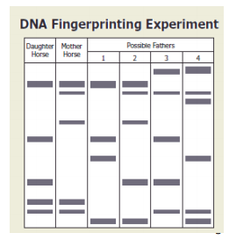
Sample Gels
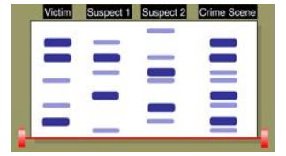
8. The diagram to the right shows DNA fingerprints from a daughter horse, the mother horse, and four possible fathers. Which horse is most likely the father? _________
9. Using the gel above, who committed the crime? ____
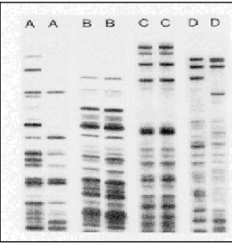
10. The gel to the right contains DNA banding patterns from four sets of twins. Which set of twins is identical? _________________
11. What molecule is used to cut DNA into fragments? __________________
12. What lab procedure would be performed if a lab technician needed more DNA to analyze from a crime scene? _______________________________
13. What lab procedure is performed to separate DNA fragments based on size? _______________________
14. A DNA ___________________________ is a pattern of dark bands on photographic film that is made when DNA fragments are separated by electrophoresis and tagged. The film is often used to determine suspects in a crime.
Section C: Genetic Engineering
Type the following link to the article, read, then answer questions 1-4. https://www.nature.com/scitable/topicpage/genetically-modified-organisms-gmos-transgenic-crops-and-732/
1. Numerous agriculture plants have been genetically modified. List benefits of genetic engineering in agriculture.
______________________________________________________________________________
______________________________________________________________________________
______________________________________________________________________________
______________________________________________________________________________
______________________________________________________________________________
2. The pharmaceutical industry is another area where genetic engineering is prevalent. List examples and benefits for genetic engineering in this area. ______________________________
______________________________________________________________________________
______________________________________________________________________________
______________________________________________________________________________
______________________________________________________________________________
3. List some examples of potential GMO applications. _____________________________________
______________________________________________________________________________
______________________________________________________________________________
4. Explain some of the risk and controversy surrounding the use of GMOs. ____________________
______________________________________________________________________________
______________________________________________________________________________
______________________________________________________________________________
5. What process alters genes to introduce desirable traits? _________________________________
6. What is a transgenic organism? ____________________________________________________
______________________________________________________________________________
7. When DNA from two different sources is spliced together, what is the DNA called?
__________________________________
8. What is the function of restriction enzymes? __________________________________________
_____________________________________________________
9. A ____________________ is a plasmid used to move foreign genes into desired host cells.
10. Scientists have changed the DNA of a type of cabbage so that it contains a tiny amount of poison from a scorpion’s tail. The poison in the cabbage kills caterpillars that try to eat it. This is an example of ____________________________________

