Behaviors are a result of __________________ _________________!

Innate Behaviors:________________________________________________________

Automatic | Reflex
 | Fight-or-Flight
Instinct | Simple | Suckling
 | More  Complex | Courtship
 |  | Territoriality
 |  | Aggression
 |  | Dominance Hierarchy
 |  | Photo- and Chemo- taxis
 | Cycles | Circadian Rhythm
 |  | Migration
 |  | Hibernation
 |  | Estivation

Learned Behaviors: _______________________________________________________

Habituation
Classical conditioning
Operant conditioning
(Trial-and-Error)
Insight/Reasoning
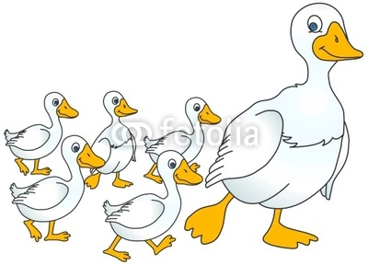
Combining Innate and Learned Behaviors
- Social Behaviors:

- Imprinting:

- Communication:

