Diagram 1: Vegetative Propagation
Some plant sends out stems that have buds that grow into new spider plants.
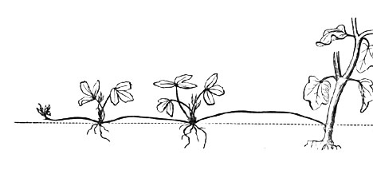

Diagram 2: Regeneration
A whole new starfish can grow from a single arm that was cut off of a starfish.
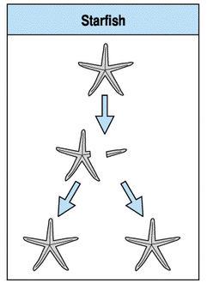

Diagram 3: Budding
Yeast are single-celled organisms that produce offspring from a bulge that forms and breaks away from the parent.
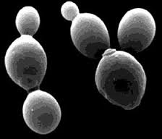

Diagram 4: Binary Fission
An Amoeba is a single-celled eukaryotic organism that reproduces by splitting in half to become two new cells.
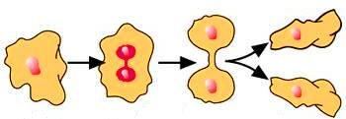

Diagram 5: Sporulation
A cell made by some plants or fungus that is like a seed and can produce a new plant or fungus.
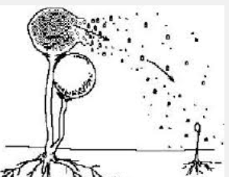

Diagram 6: Regeneration
A Planarian is a tiny flatworm that lives in ponds. If a Planarian is cut into pieces, each piece will grow into a new Planarian.
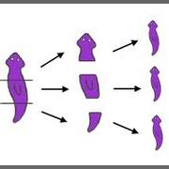

Diagram 7: Binary Fission
A bacterium is a single-celled prokaryotic organism that reproduces by splitting in half to become two new cells.

